Chapter Prayer with Mary

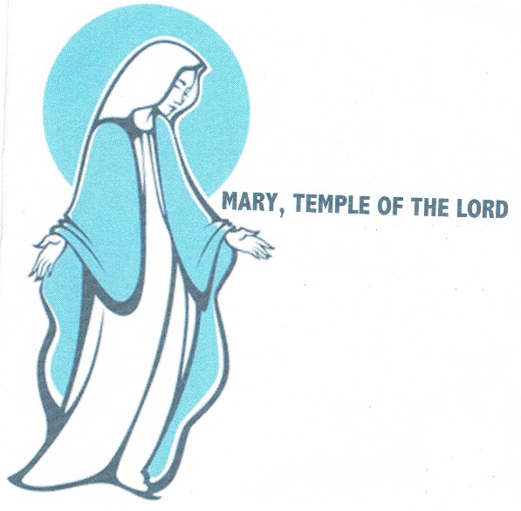
Mary of the Presentation,
you who, moved by the Holy Spirit,
welcomed the word of life
in the depths of your humble faith:
as you gave yourself completely to the Eternal One,
help us to say our own ‘yes’
to the call of our Chapter,
to proclaim the good news of Jesus.
Brimming over with joy,
you sang of the great things done by God.
Obtain for us now a new ardour born of
the resurrection that we may bring to all
the Gospel of life, in the spirit of Blessed Edmund Rice.
Journey with us now and teach us to
be pilgrim Brothers with the compassionate
Christ in an evolving world.
Amen. Alleluia!

